Online Shopping System: FOOTFUSION

Use-Case-Realization Specification: View Payment Methods

Version <1.0>

Revision History
Date | Version | Description | Author
<25/11/2024> | <1.0> | Final Draft | Vũ Trí Nguyện

Table of Contents
1. Introduction 2
1.1 Purpose 2
1.2 Scope 2
1.3 Definitions, Acronyms, and Abbreviations 2
1.4 References 2
1.5 Overview 2
2. Flow of Events—Design 2
3. Derived Requirements 2

Use-Case-Realization Specification: View Payment Methods

Introduction

Purpose
This document describes how the View Payment Methods Use-Case is realized within the design model, in terms of collaborating objects.

Scope
This document applies to the FootFusion Online Shopping System.

Definitions, Acronyms, and Abbreviations
Administrator.

References
Use Case Specification – View Payment Methods.

Overview
This document provides the Use-Case Realization Specification of the View Payment Methods Use-Case for the FootFusion Online Shopping System. It includes a textual description of the use case realization, a sequence diagram, a class diagram, and an analysis of any derived requirements..

Flow of Events—Design
Administrator views payment methods in the system.

Sequence Diagram
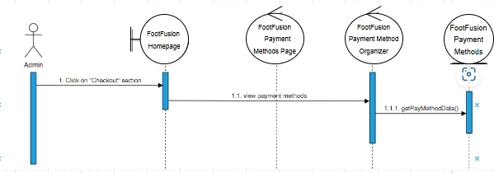

Class Diagram

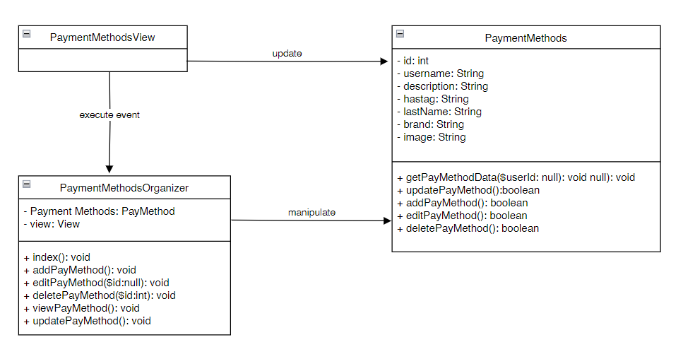

Derived Requirements
There is no derived requirement.

